**Session 3**

**-**

**User library for GPIO control**

**Author:** Guillermo Cortés Orellana

**Teacher:** Tomáš Frýza



Lab assignment

1. **Preparation tasks**

* Table with data type

|  |  |  |  |
| --- | --- | --- | --- |
| Data type | Number of bits | Range | Description |
| uint8_t | 8 | 0, 255 | Unsigned 8-bit integer |
| int8_t | 8 | -128, 127 | Signed 8-bit integer |
| uint16_t | 16 | 0, 65535 | Unsigned 16-bit integer |
| int16_t | 16 | -32768, 32767 | Signed 16-bit integer |
| float | 32 | -3.4E38, 3.4E38 | Single-precision floating-point |
| void | 0 | - | No value |

* Source code completed from the example

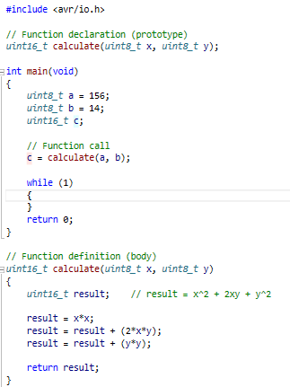

1. **GPIO library**

* Listing of library source file ***gpio.c***

**Note:** functions prototypes are in ***gpio.h*** file

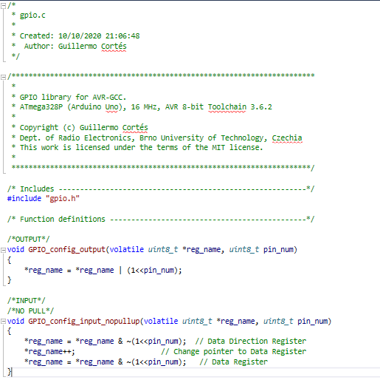

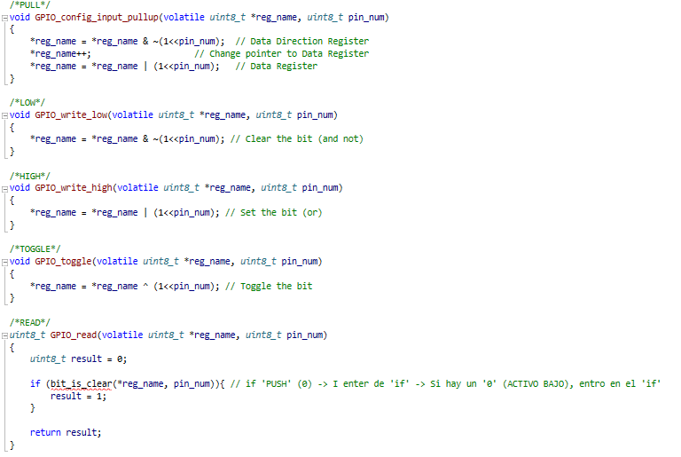

You can find the code on my GitHub:

https://github.com/GuicoRM/Digital-Electronics-2

* C code of the application ***main.c***

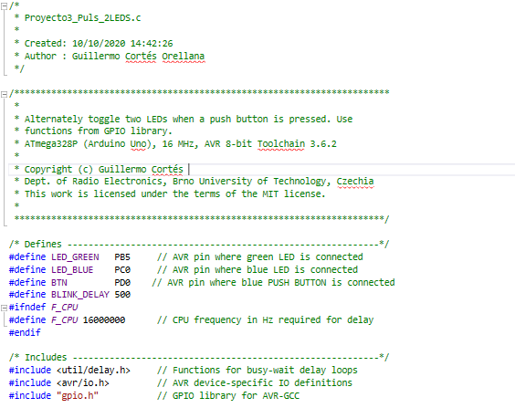

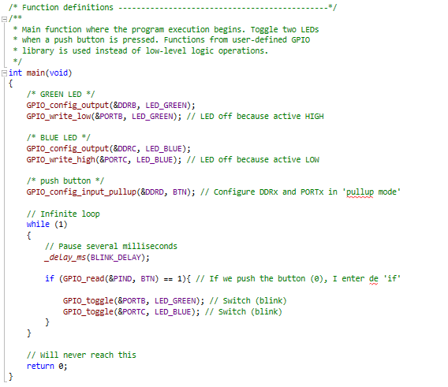

You can find the code on my GitHub:

https://github.com/GuicoRM/Digital-Electronics-2

* Difference between the declaration and the definition of the function in C
* **Declaration:** part of the code where is included some information related to the own function (name, parameters, return type). It could help others programmers to understand the code and the goal of the function. It is normally included in **.h** file.
* **Definition:** in contradistinction to the declaration, the definition implements the task which the function will carry out. It is normally included in **.c** file and “contains“ the structure of the declaration.
* **Example:**

**Declaration → .h file**

*int example_add_2_numbers (int num1, int num2);*

**Definition → .c file**

*int example_add_2_numbers (int num1, int num2){*

*\*Code that allows adding 2 numbers\**

*}*